Project Design Phase-II
Data Flow Diagram & User Stories
Date | 16-10-2026
Team ID | SWUID2026399565
Project Name | IMovies – Movie Ticket Booking Made Simple
Maximum Marks | 4 Marks
Data Flow Diagrams:
A Data Flow Diagram (DFD) illustrates how data moves within the IMovies platform. It captures how users (customers and admins) interact with the system, how information flows between different components, and where the data is stored.

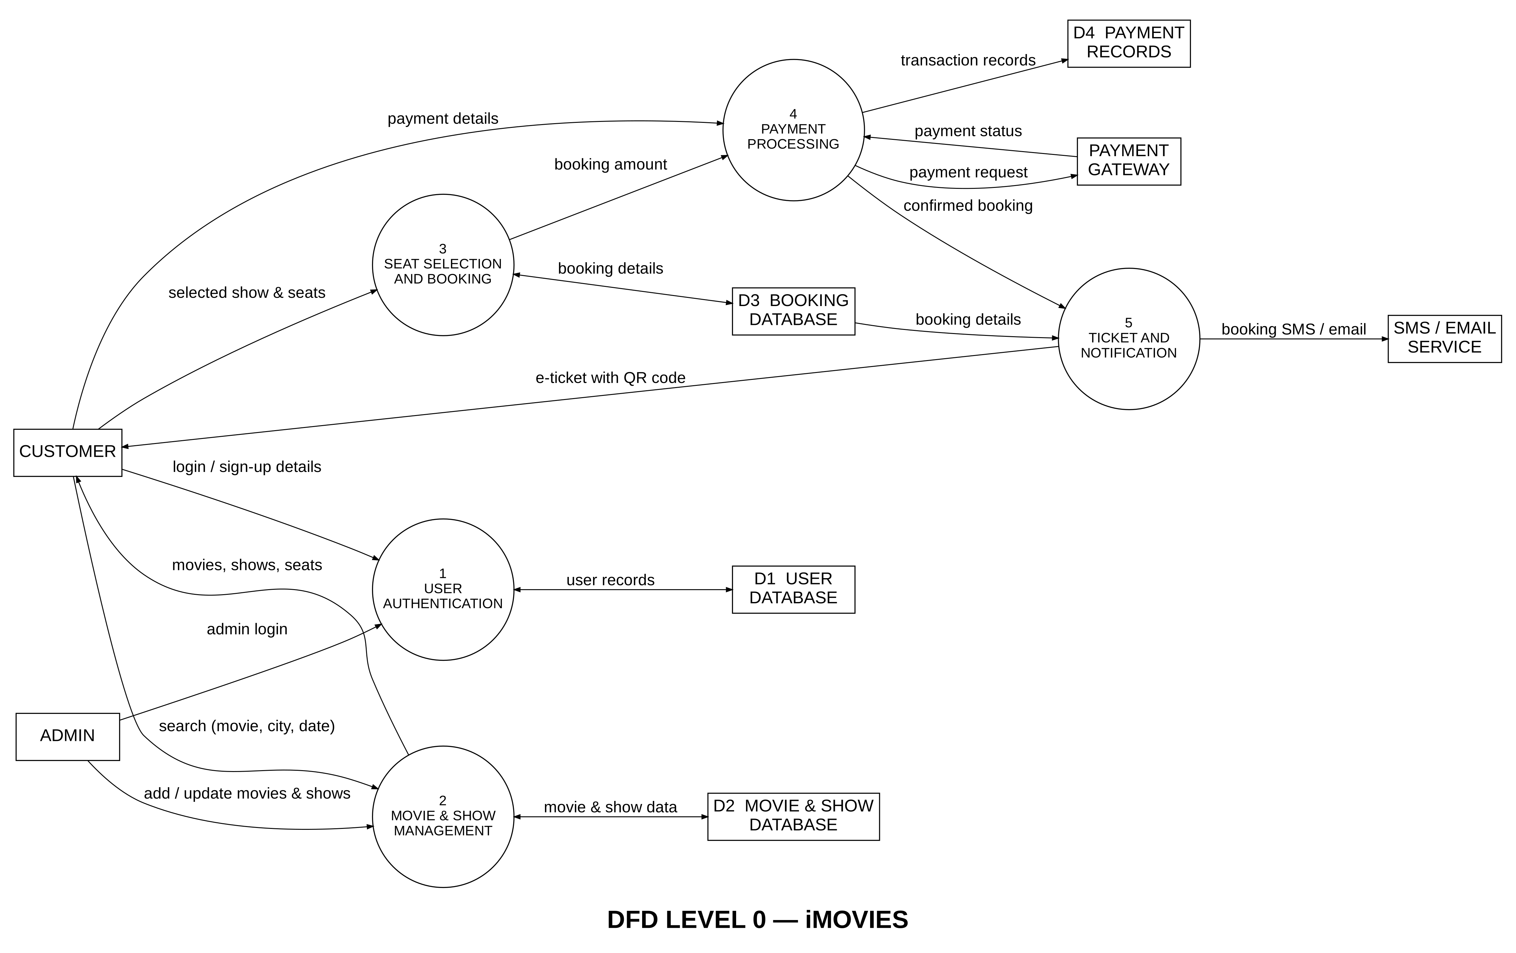

User Stories
User Story Table – IMovies
User Type | Functional Requirement (Epic) | User Story / Task | Acceptance Criteria | Priority | Release
Customer | Registration & Login | As a customer, I can sign up and log in using my email or mobile number. | Account is created and I land on the home page. | High | Sprint-1
Customer | Movie Browsing | As a customer, I can search movies by city, language and date. | Matching movies and show timings are listed. | High | Sprint-1
Customer | Seat Selection | As a customer, I can view the seat layout and pick my seats. | Booked seats are blocked and my selected seats are highlighted. | High | Sprint-1
Customer | Payment Processing | As a customer, I can pay securely using UPI, card or net banking. | Payment status is shown and saved in my payment history. | High | Sprint-2
Customer | Ticket Confirmation | As a customer, I can receive an e-ticket with a QR code after payment. | Ticket is sent by SMS/email and appears in My Bookings. | High | Sprint-2
Customer | Booking Cancellation | As a customer, I can cancel a booking before the show starts. | Seats are released and the refund status is shown. | Medium | Sprint-2
Customer | Reviews & Ratings | As a customer, I can rate and review a movie after watching it. | Review appears on the movie page. | Low | Sprint-3
Admin | Movie & Show Management | As an admin, I can add or update movies, theatres and show timings. | Changes appear in search results right away. | High | Sprint-1
Admin | Booking Reports | As an admin, I can view booking and payment reports. | Reports show correct totals by date and theatre. | Medium | Sprint-3

